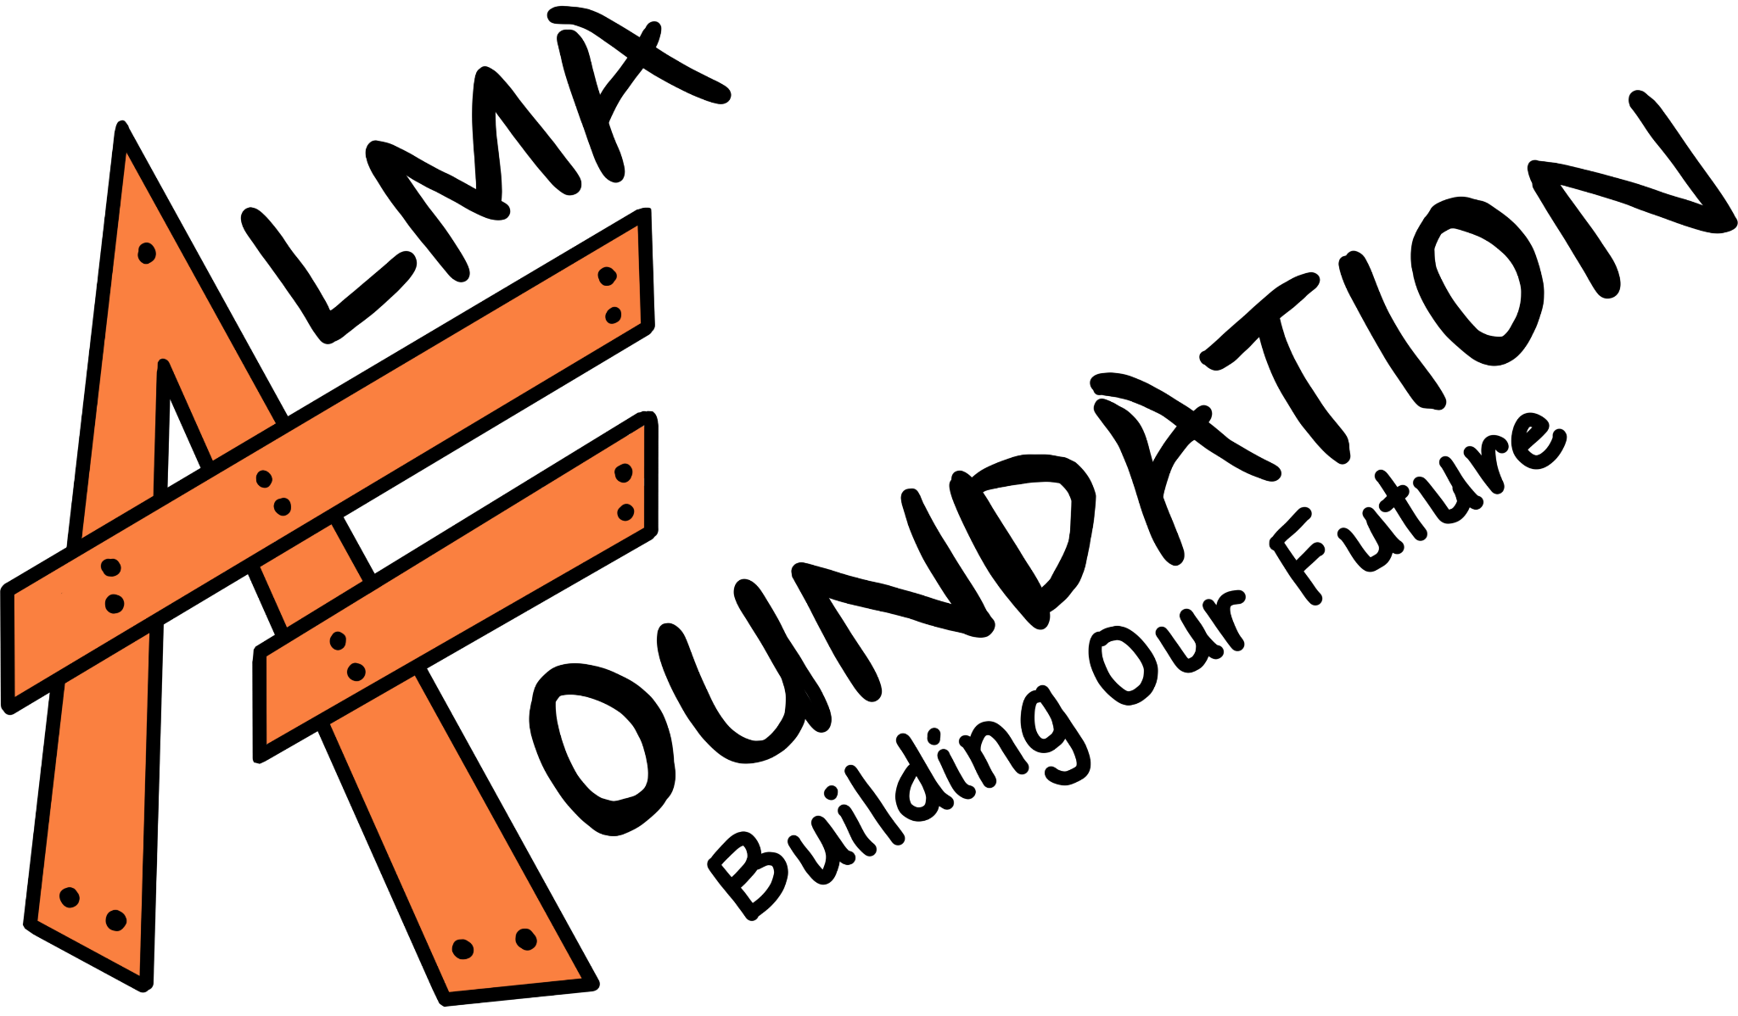
Alma Foundation - Continuing Education Student Scholarship Application
The Alma Foundation is a nonprofit organization focusing on community enrichment projects in Alma, Colorado, North America's highest incorporated town at 10,578ft. The Foundation is organized to foster, encourage, and promote charitable, educational, scientific, and cultural activities, to support projects which normally would not be provided for by tax dollars, and to further the quality of life in the Alma community. The Alma Foundation hosts community engagement events, some of which raise funds dedicated to supporting local graduating students bound for College, Trade School, or a Career Program.
Please visit www.almafoundation.com to learn more.

APPLICANT INFORMATION
Full Name:

Mailing Address:

City / State / ZIP:

Phone Number:

Email Address:

Date of Birth:

SCHOOL INFORMATION
Current High School:

GPA (on a 4.0 scale):

POST-SECONDARY EDUCATION PLANS
Intended Pathway (check one):
☐ College / University
☐ Trade School / Technical Program
☐ Apprenticeship / Certification Program
Name of School or Program:

Anticipated Start Date:

Intended Field of Study or Trade:

ACTIVITIES & ACHIEVEMENTS
List extracurricular activities, employment, volunteer work, athletics, or leadership roles.

LETTER OF RECOMMENDATION
Please attach one letter of recommendation from a teacher, counselor, employer, or community leader.

ESSAY QUESTIONS
Typed responses are strongly preferred. Each response should be 200–300 words.
Connection to Community
The Alma Foundation is a nonprofit serving the community of Alma. How have you been involved in your local community? How would you like to serve your community in the future?
Personal Statement
Describe a challenge you have overcome or a defining experience that has shaped who you are today.

SIGNATURE
I certify that the information provided in this application is true and complete to the best of my knowledge. All words and expressions are my own.
Applicant Signature:

Date: ____________________________

SUBMISSION INSTRUCTIONS
Completed applications must be submitted by: APRIL 26, 2026
Please submit your completed application to the Alma Town Hall during business hours, or to Ms. Hatch, the guidance counselor at South Park High School. Scanned applications can also be emailed to almafoundationcolorado@gmail.com.
Please email almafoundationcolorado@gmail.com with any questions.
Thank you for applying for the Alma Foundation - Continuing Education Student Scholarship!

